Enzymes 2
A substance that is acted upon (either broken down or joined together) by an enzyme is called its substrate. The active site is a region on the surface of the enzyme molecule where a substrate molecule can attach itself. It’s where the catalysed reaction takes place. The shape of the substrate molecule and the shape of the active site are complementary, i.e. they fit each other like pieces in a puzzle. Almost as soon as the enzyme-substrate complex has formed, the products of the reaction are released and the enzyme is ready to accept another substrate molecule.

Task 1: Add the following labels to the enzyme diagram below
Enzyme-substrate complex // Enzyme molecule // Substrate fits into active site // Substrate molecule // Enzyme ready to accept another substrate molecule // Active site // Products
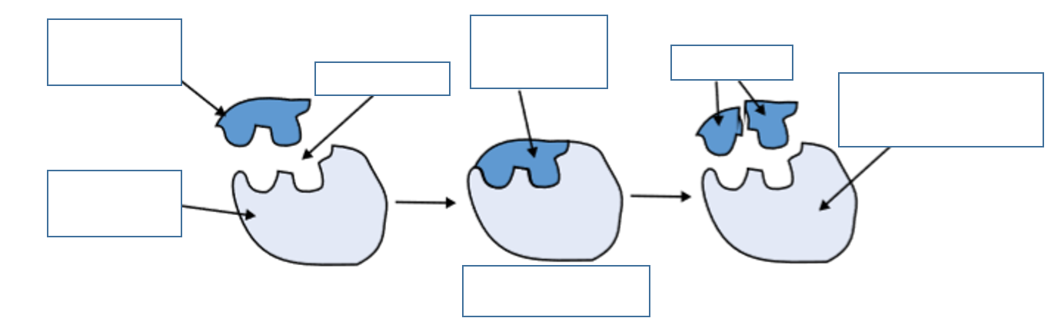
Task 2: Correct the following statements about enzymes
- An enzyme usually catalyses many different reactions
- Substrate molecules don’t need to be the correct shape to fit into an active site
- Any substrate molecule can fit into the active site of any enzyme
- If a substance changes the shape of the active site the enzyme will work better
Task 3: Complete the paragraph below about the effects of temperature and pH on enzyme activity
Temperature
As temperature increases, enzyme reactions become _________, because the molecules have more _________. However, at high temperatures the atoms of the enzyme molecule _________ more rapidly and _________ the weak bonds that hold the tertiary structure together. The shape of the _______ ____ changes and the substrate can no longer fit in. The enzyme is said to be ____________.
pH
Acids and alkalis can also __________ enzymes. Hydrogen ions (H+) in acids and hydroxyl ions (OH-) in alkalis disrupt the weak bonds of the __________ structure and this change the shape of the ________ ____.
Last task! Complete the questions
- Why are enzymes described as ‘specific’?
- Explain why a denatured enzyme will not function.
- Describe the effect of pH on enzyme activity.
Extension:
What are competitive and non-competitive inhibitors? How are they different? How do they link in with enzymes?

