Light Microscopy:
This is the oldest, simplest and most widely-used form of microscopy. Specimens are illuminated with light, which is focussed using glass lenses and viewed using the eye or photographic film. Specimens can be living or dead, but often need to be stained with a coloured dye to make them visible. Many different stains are available that stain specific parts of the cell such as DNA, lipids, cytoskeleton, etc. All light microscopes today are compound microscopes, which means they use several lenses to obtain high magnification. Light microscopy has a resolution of about 200 nm, which is good enough to see cells, but not the details of cell organelles. There has been a recent resurgence in the use of light microscopy, partly due to technical improvements, which have dramatically improved the resolution far beyond the theoretical limit. For example fluorescence microscopy has a resolution of about 10 nm, while interference microscopy has a resolution of about 1 nm.

Preparation of Slide Samples
- Fixation: Chemicals preserve material in a life like condition. Does not distort the specimen.
- Dehydration: Water removed from the specimen using ethanol. Particularly important for electron microscopy because water molecules deflect the electron beam which blurs the image.
- Embedding: Supports the tissue in wax or resin so that it can be cut into thin sections.
Sectioning Produces very thin slices for mounting. Sections are cut with a microtome or an ultramicrotome to make them either a few micrometres (light microscopy) or nanometres
(electron microscopy) thick.
- Staining: Most biological material is transparent and needs staining to increase the contrast between different structures. Different stains are used for different types of tissues. Methylene blue is often used for animal cells, while iodine in KI solution is used for plant tissues.
- Mounting: Mounting on a slide protects the material so that it is suitable for viewing over a long period.
Electron Microscopy
This uses a beam of electrons, rather than electromagnetic radiation, to "illuminate" the specimen. This may seem strange, but electrons behave like waves and can easily be produced (using a hot wire), focused (using electromagnets) and detected (using a phosphor screen or photographic film). A beam of electrons has an effective wavelength of less than 1 nm, so can be used to resolve small sub-cellular ultrastructure. The development of the electron microscope in the 1930s revolutionised biology, allowing organelles such as mitochondria, ER and membranes to be seen in detail for the first time.
The main problem with the electron microscope is that specimens must be fixed in plastic and viewed in a vacuum, and must therefore be dead. Other problems are that the specimens can be damaged by the electron beam and they must be stained with an electron-dense chemical (usually heavy metals like osmium, lead or gold). Initially there was a problem of artefacts (i.e. observed structures that were due to the preparation process and were not real), but improvements in technique have eliminated most of these.
There are two kinds of electron microscope. The transmission electron microscope (TEM) works much like a light microscope, transmitting a beam of electrons through a thin specimen and then focusing the electrons to form an image on a screen or on film. This is the most common form of electron microscope and has the best resolution. The scanning electron microscope (SEM) scans a fine beam of electron onto a specimen and collects the electrons scattered by the surface. This has poorer resolution, but gives excellent 3-dimentional images of surfaces.
Transmission Electron Microscope (TEM) | Scanning Electron Microscope (SEM)
- Pass a beam of electrons through the specimen. The electrons that pass through the specimen are detected on a fluorescent screen on which the image is displayed.  - Thin sections of specimen are needed for transmission electron microscopy as the electrons have to pass through the specimen for the image to be produced.  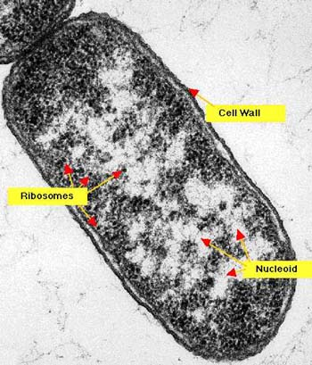  - This is the most common form of electron microscope and has the best resolution | - Pass a beam of electrons over the surface of the specimen in the form of a ‘scanning’ beam.  - Electrons are reflected off the surface of the specimen as it has been previously coated in heavy metals.  - It is these reflected electron beams that are focussed of the fluorescent screen in order to make up the image.  - Larger, thicker structures can thus be seen under the SEM as the electrons do not have to pass through the sample in order to form the image. This gives excellent 3-dimensional images of surfaces  - However the resolution of the SEM is lower than that of the TEM.  

