A Level Geography
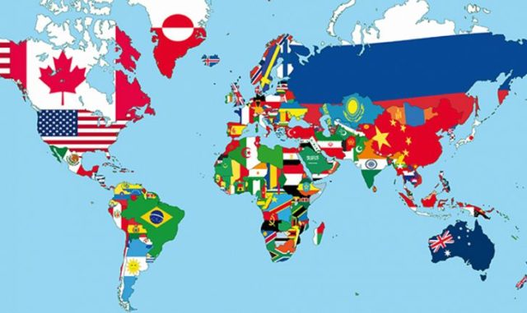

Name: _________________________________________

In Year 12 you will study four topics – Tectonic processes and hazards, Coastal landscapes and change, Globalisation and Regenerating places. The aim of this booklet is to give you an idea of what we will be studying and allow you to prepare for the skills and exam style questions you will be expected complete.

Topic 1 - Tectonic Processes and Hazards.

Enquiry Questions:

1. Why are some locations more at risk from tectonic hazards?
2. Why do some tectonic hazards develop into disasters?
3. How successful is the management of tectonic hazards and disasters?

This topic develops your knowledge from GCSE.

Use the information below, your own knowledge AND additional research to complete the tasks below.

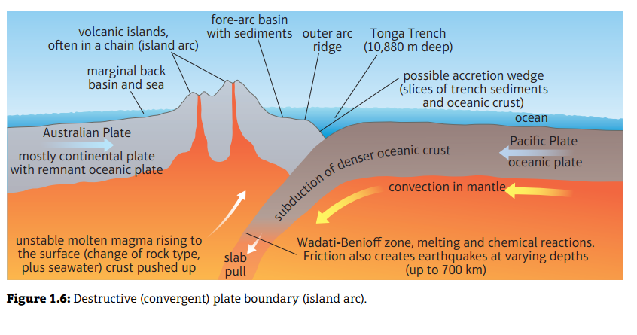
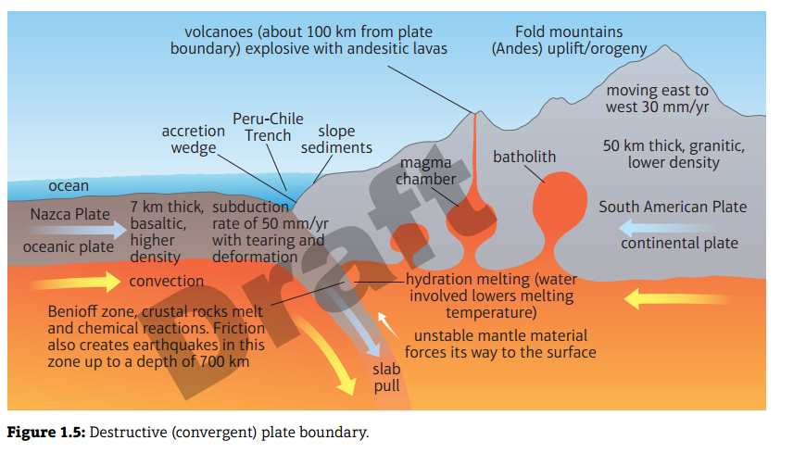
Plate Boundaries
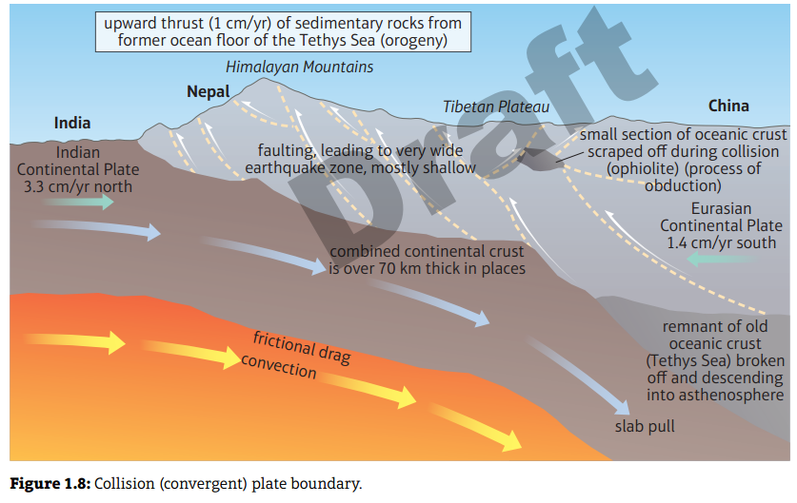
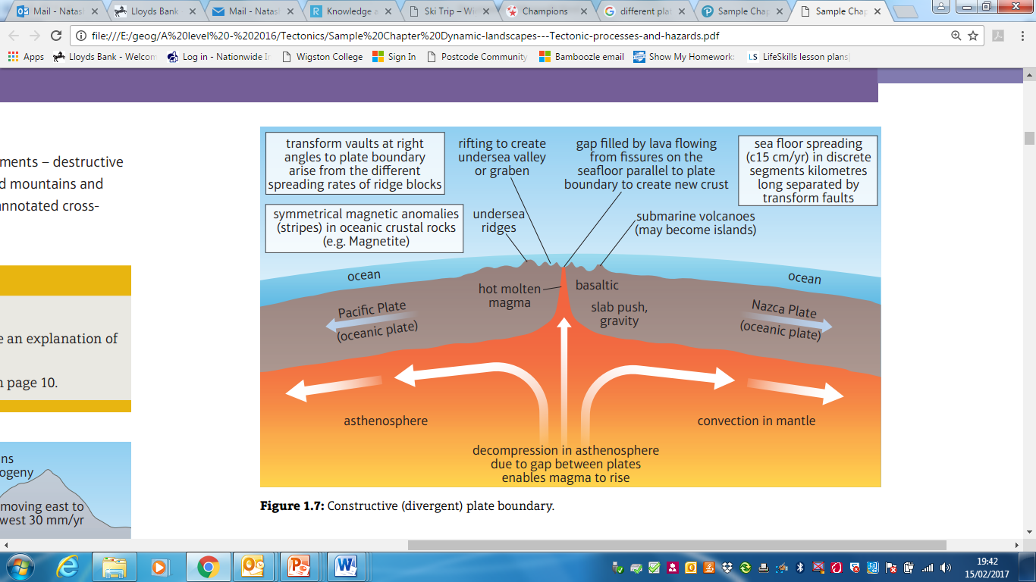

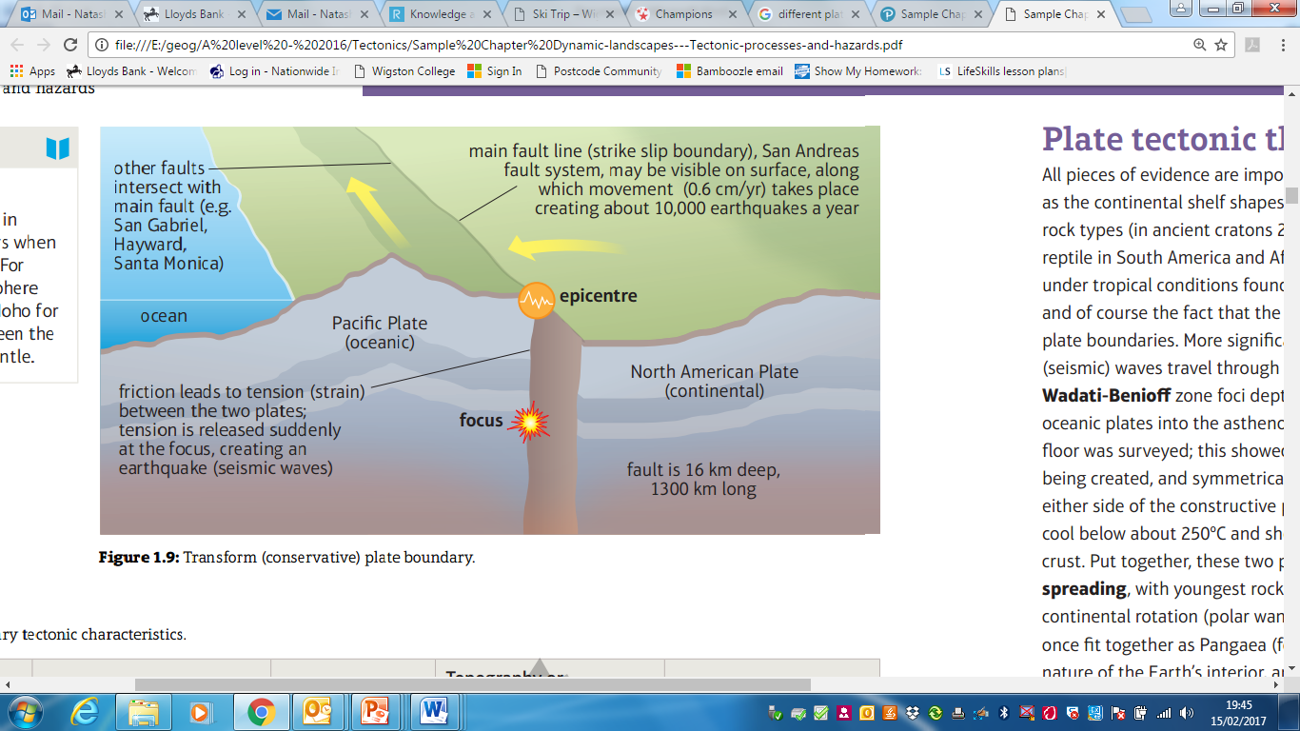
1. For each plate boundary identify the different tectonic hazards and the key features.
Plate boundary | Earthquakes and/or volcanoes | Key features (direction of plate margin, type of plate,
Destructive
Constructive
Collision
Transform (Conservative)

2 - Explain the cause of earthquakes at constructive plate margins (4)
………………………………………………………………………………………………………………………………………………………………………………………………………………………………………………………………………………………………………………………………………………………………………………………………………………………………………………………………………………………………………………………………………………………………………………………………………………………………………………………………………………………………………………………………………………………………………………………………………………………………………………………………………………………………………………………………………………………………………………………………………………………………………………………………………………………………………………………………………………………………………………………………………………………………………………………………………………………………………………………………………………………………………………………………………………………………………………………………………………………………………………………

3 - Explain the cause of volcanoes at destructive plate margins (4)
…………………………………………………………………………………………………………………………………………………………………………………………………………………………………………………………………………………………………………………………………………………………………………………………………………………………………………………………………………………………………………………………………………………………………………………………………………………………………………………………………………………………………………………………………………………………………………………………………………………………………………………………………………………………………………………………………………………………………………………………………………………………………………………………………………………………………………………………………………………………………………………………………………………………………………………………………………………………………………………………………………………………………………………………………………………………………………………………………………………………………………………………………………………………………………………………………………………………………………………………………………………….…

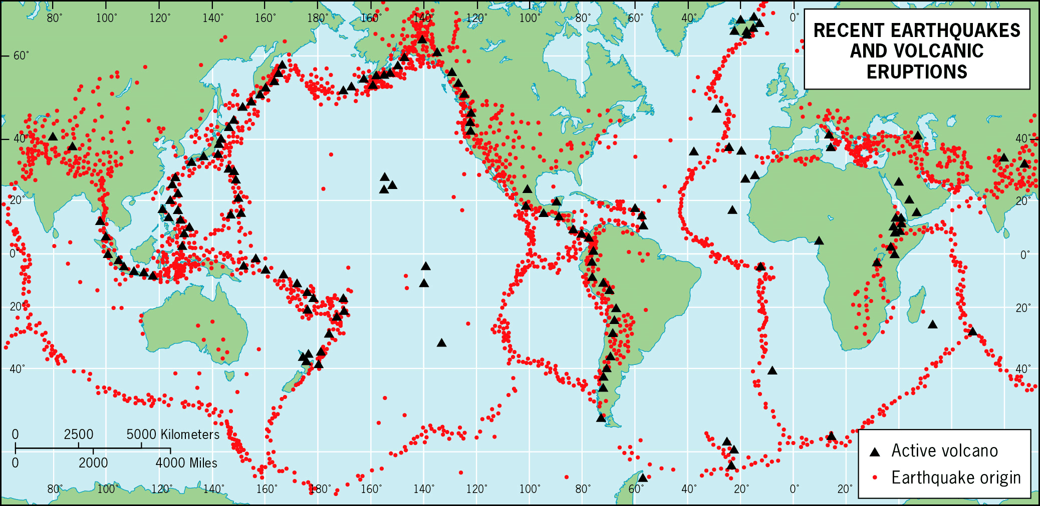
4. Explain why earthquakes and volcanoes are often located in similar locations (6)

……………………………………………………………………………………………………………………………………………………………………………………………………………………………………………………………….…………………………………………………………………………………………………………………………………………………………………………………………………………………………………………………………………………………………………………………………………………………………………………………………………………………………………………………………………………………………………………………………………………………………………………………………………………………………………………………………………………………………………………………………………………………………………………………………………………………………………………….………………………………………………………………………………………………………………………………………………………………………………………………………………………………………………………………………………………………………………………………………………………………………………………………………………………………………………………………………………………………………………………………………………………………………………………………………………………………………………………………………………………………………………………………………………
5 - Case Study – Research

Complete research into one of the following hazards and produce a comprehensive case study with photographs and maps to support your research:

- Volcanic Eruption – Eyjafjallajokull, Iceland 2011
- Earthquake – Christchurch, New Zealand 2010 and 2011

For either hazard identify the cause, impacts (Social, Economic and Environmental) and Management of the hazard.

Topic 2 – Coastal landscape and change

Enquiry Questions:

1: Why are coastal landscapes different and what processes cause these differences?
2: How do characteristic coastal landforms contribute to coastal landscapes?
3: How do coastal erosion and sea level change alter the physical characteristics of coastlines and increase risks?
4: How can coastlines be managed to meet the needs of all players?

This topic also develops your knowledge from GCSE. Use the information below, your own knowledge AND additional research to complete the tasks below.

Coastal landscapes

The Jurassic Coastline in Dorset is one of the most famous stretches of coastline in terms of landforms and features.

1 - Your task is to research this stretch of coastline to create a case study. You will need to include photos and annotated maps to identify the different features along this stretch of coastline and start to explain how and why the different landforms are created.

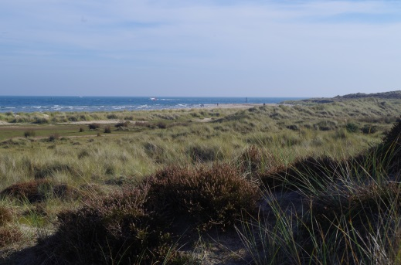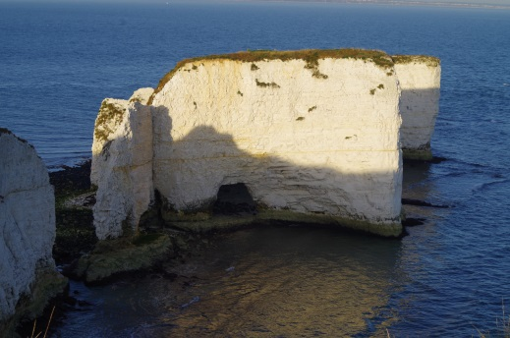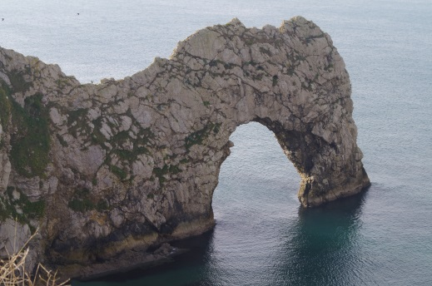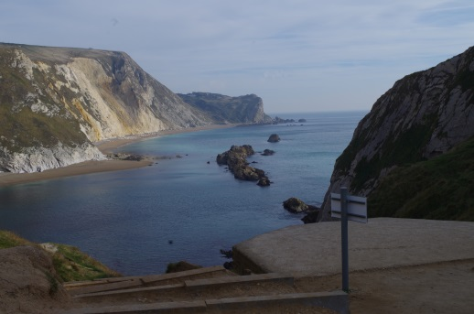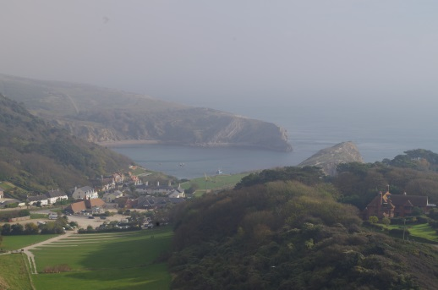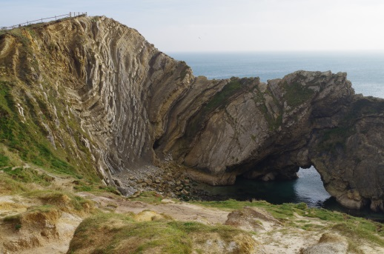

2 - Explain the relationship between geology and coastal form along the Dorset Coastline (6 marks)

……………………………………………………………………………………………………………………………………………………………………………………………………………………………………………………………….…………………………………………………………………………………………………………………………………………………………………………………………………………………………………………………………………………………………………………………………………………………………………………………………………………………………………………………………………………………………………………………………………………………………………………………………………………………………………………………………………………………………………………………………………………………………………………………………………………………………………………….………………………………………………………………………………………………………………………………………………………………………………………………………………………………………………………………………………………………………………………………………………………………………………………………………………………………………………………………………………………………………………………………………………………………………………………………………………………………………………………………………………………………………………………………………………

3 – Explain the location of depositional landforms along the Dorset Coastline (6 marks)

……………………………………………………………………………………………………………………………………………………………………………………………………………………………………………………………….…………………………………………………………………………………………………………………………………………………………………………………………………………………………………………………………………………………………………………………………………………………………………………………………………………………………………………………………………………………………………………………………………………………………………………………………………………………………………………………………………………………………………………………………………………………………………………………………………………………………………………….………………………………………………………………………………………………………………………………………………………………………………………………………………………………………………………………………………………………………………………………………………………………………………………………………………………………………………………………………………………………………………………………………………………………………………………………………………………………………………………………………………………………………………………………………………

Topic 3 – Globalisation
Enquiry questions
- What are the causes of globalisation and why has it accelerated in recent decades?
- What are the impacts of globalisation for different countries, different groups of people and cultures and the physical environment?
- What are the consequences of globalisation for global development and the physical environment and how should different players respond to its challenges?

Globalisation is the process by which people, culture, finance, goods and information transfer between countries with few barriers.

Your task is to research the numerous players, attitudes and actions that have been responsible for promoting globalisation and to assess the winners and losers in increased globalisation.


1. Who are these Organisations and what role do they play in globalisation?


2. How do global trading blocs affect globalisation, how many blocs are these and how important are they in global trade?


3. What role do TNCs play in the globalisation process?


4. Why are the benefits of globalisation not equal? What are the barriers to globalisation?


5. What are the main arguments against globalisation?


6. To what extent was the spread of this caused by globalisation and to what extent is the cure reliant on globalisation?

Exam style questions

1. Explain two ways that national government have contributed to globalisation (4)

………………………………………………………………………………………………………………………………………………………………………………………………………………………………………………………………………………………………………………………………………………………………………………………………………………………………….…………………………………………………………………………………………………………………………………………………………………………………………………………………………………………………………………………………………………………………………………………………………………………………………………………

2. Explain why some locations remain ‘switched off’ from globalisation (6)

……………………………………………………………………………………………………………………………………………………………………………………………………………………………………………………………….…………………………………………………………………………………………………………………………………………………………………………………………………………………………………………………………………………………………………………………………………………………………………………………………………………………………………………………………………………………………………………………………………………………………………………………………………………………………………………………………………………………………………………………………………………………………………………………………………………………………………………….………………………………………………………………………………………………………………………………………………………………………………………………………………………………………………………………………………………………………………………………………………………………………………………………………………………………………………………………………………………………………………………………………………………………………………………………………………………………………………………………………………………………………………………………………………

Topic 4 - REGENERATING PLACES
Enquiry questions
- How and why do places vary?
- Why might regeneration be needed?
- How is regeneration managed?
- How successful is regeneration?
This topic also develops your knowledge from GCSE. Use the information below, your own knowledge AND additional research to complete the tasks below.

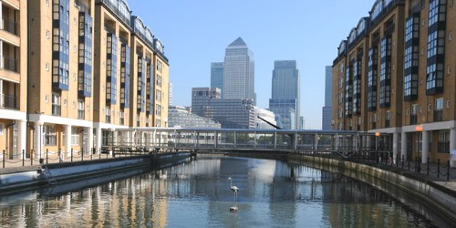
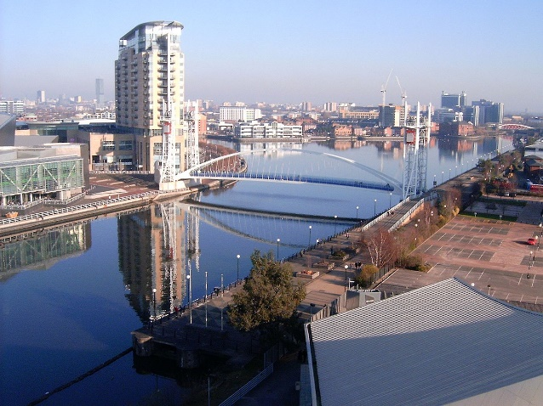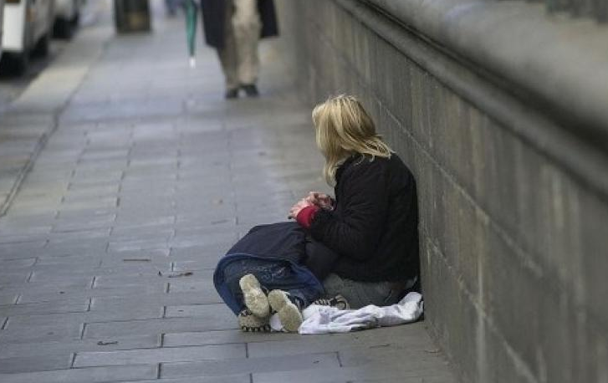

1. HOW AND WHY DO PLACES VARY?
What is the geography of Kent?
How has the geology and landscape of Kent created a distinct county?
How have humans sculpted this landscape to create a Kentish Identity?
How has the industrial history of Sittingbourne shaped its current and future economic potential?

2: WHY MIGHT REGENERATION BE NEEDED?
Why did Sittingbourne need to be regenerated?
Use the internet, local libraries, the Records Office and your own knowledge to find out why Sittingbourne needed to be regenerated. You need to consider a wide range of questions and find out if they applied or apply to Sittingbourne, such as;
- Has the town experienced deindustrialisation?
- Have industries closed down and for what reasons?
- What was/is the level of unemployment?
- Are there skills shortages?
- Has the area experienced outward migration?
- What has happened to property prices?
- Does the area suffer from social deprivation (health, education, crime and access to services)?
- Is there any evidence of sink estates, commuter villages or declining rural settlements?
- Are local communities engaged in the area (consider election turnout and local community groups)?
- What is the ethnic mix/make-up of the area?
- What is the population structure of the area?
- Are there many new residents (students, in-migrants)?
- Is there evidence of conflict between different groups within communities?
- What were the original aims of The Spirit of Sittingbourne regeneration scheme?
- To what extent have these aims been met?

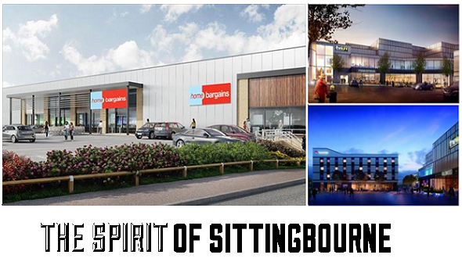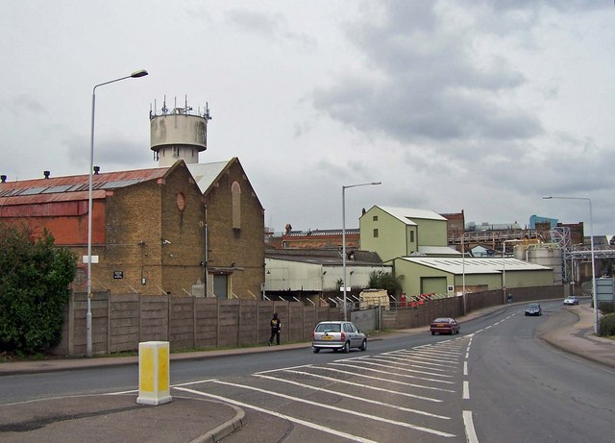

3: HOW IS REGENRATION MANAGED?
Has national government made any policy decisions that have had an impact on Sittingbourne’s regeneration?
- Have they improved transport infrastructure?
- Have they passed new planning laws?
- Have they set house building targets?
- Have they made decisions about international migration?

Has local government taken decisions to make the area look more attractive to inward investors?
- Have they created science parks, industrial estates to attract new firms to the area?
- Are local interest groups (Chamber of Commerce, preservation societies) involved in the key decision-making process in the area?
- Have they been involved in any leisure and tourism, retail or sport strategies to regenerate the area?
- Have they encouraged rural diversification?

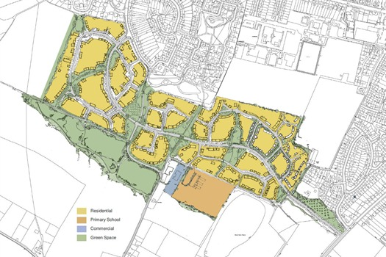

4. How successful is regeneration?
Has rebranding taken place to change the public’s perception of the area?
- Has the area experienced any urban or rural rebranding?
- Has the urban area been rebranded around industry, culture, heritage or sport?
- Has the rural area around the town been rebranded around specialist products, outdoor pursuits, heritage or film?

REGENERATING PLACES GLOSSARY
Complete the glossary, remembering that the terms are all related to regenerating places, in either urban or rural areas.
- Area based incentives
- Community groups
- Commuter villages
- Deindustrialisation
- Demographic changes
- Depopulation
- Deprivation
- Environmental inequality
- Flagship regeneration projects
- Gated communities
- Gentrification
- High Speed One (HS1)
- Index of Multiple Deprivation (IMD)
- Indicators of success
- Legacy
- Levels of engagement
- Lived experience
- Local Enterprise Partnership (LEP)
- Marginalisation
- Not In My Back Yard (NIMBY) groups
- Postcode lottery (NOT the People’s postcode lottery!)
- Rebranding
- Regeneration
- Regeneration strategies
- Re-imaging
- Rural – urban continuum
- Rural proofing
- Service inequality
- Sink estate
- Social inequality
- Social polarisation
- Social segregation
- Spiral of decline / De- multiplier effect
- Studentification
Exam style questions

1. Explain reasons why a place you have studied needed to be regenerated. (6 marks)
……………………………………………………………………………………………………………………………………………………………………………………………………………………………………………………………….…………………………………………………………………………………………………………………………………………………………………………………………………………………………………………………………………………………………………………………………………………………………………………………………………………………………………………………………………………………………………………………………………………………………………………………………………………………………………………………………………………………………………………………………………………………………………………………………………………………………………………….………………………………………………………………………………………………………………………………………………………………………………………………………………………………………………………………………………………………………………………………………………………………………………………………………………………………………………………………………………………………………………………………………………………………………………………………………………………………………………………………………………………………………………………………………………

2. Explain how local government can have an impact on regeneration. (4 marks)
……………………………………………………………………………………………………………………………………………………………………………………………………………………………………………………………….…………………………………………………………………………………………………………………………………………………………………………………………………………………………………………………………………………………………………………………………………………………………………………………………………………………………………………………………………………………………………………………………………………………………………………………………………………………………………………………………………………………………………………………………………………………………………………………………………………………………………………….……………………………………………………………………

