BTEC Level 3 IT
DIGITAL DEVICES
Read the information and complete the tasks on thej next page
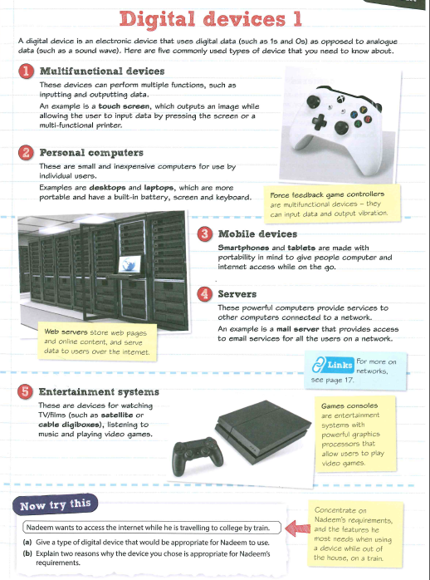

Read the notes:
Task 1 - Give two example of each type of digital device and explain how they might be used. Add images to aid your explanations.
Multifunctional devices

Personal computers

Mobile devices

Servers

Task 2 -
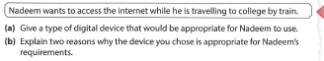

Task 3 what are the following types of digital devices and give 2 examples of how each could be used:

Digital Camera

Navigation System

Communication devices

Data capture and collection systems

Task 4
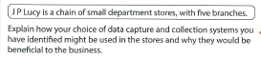

Extension task - Produce a mind map of the information in these notes

