BTEC Level 3 IT
PART 2 – USE OF DIGITAL DEVICES
Read the information and complete the tasks on the next page
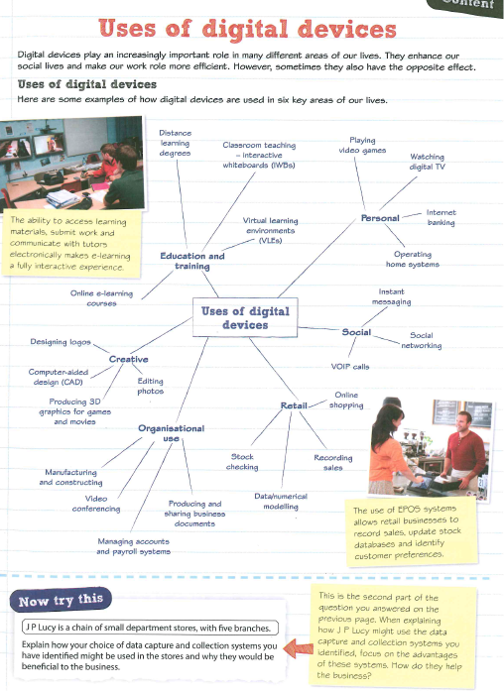

Task 1 - create a mind map of how you uses digital devices

Task 2 - create a mind map of how one of your older relatives uses digital devices

Task 3 - create a mind map of how a health club could use digital devices to improve their customer experience.

Task 4


