BTEC Level 3 IT
PART 3 – INPUT & OUTPUT DEVICES
Read the information and complete the tasks on the next page
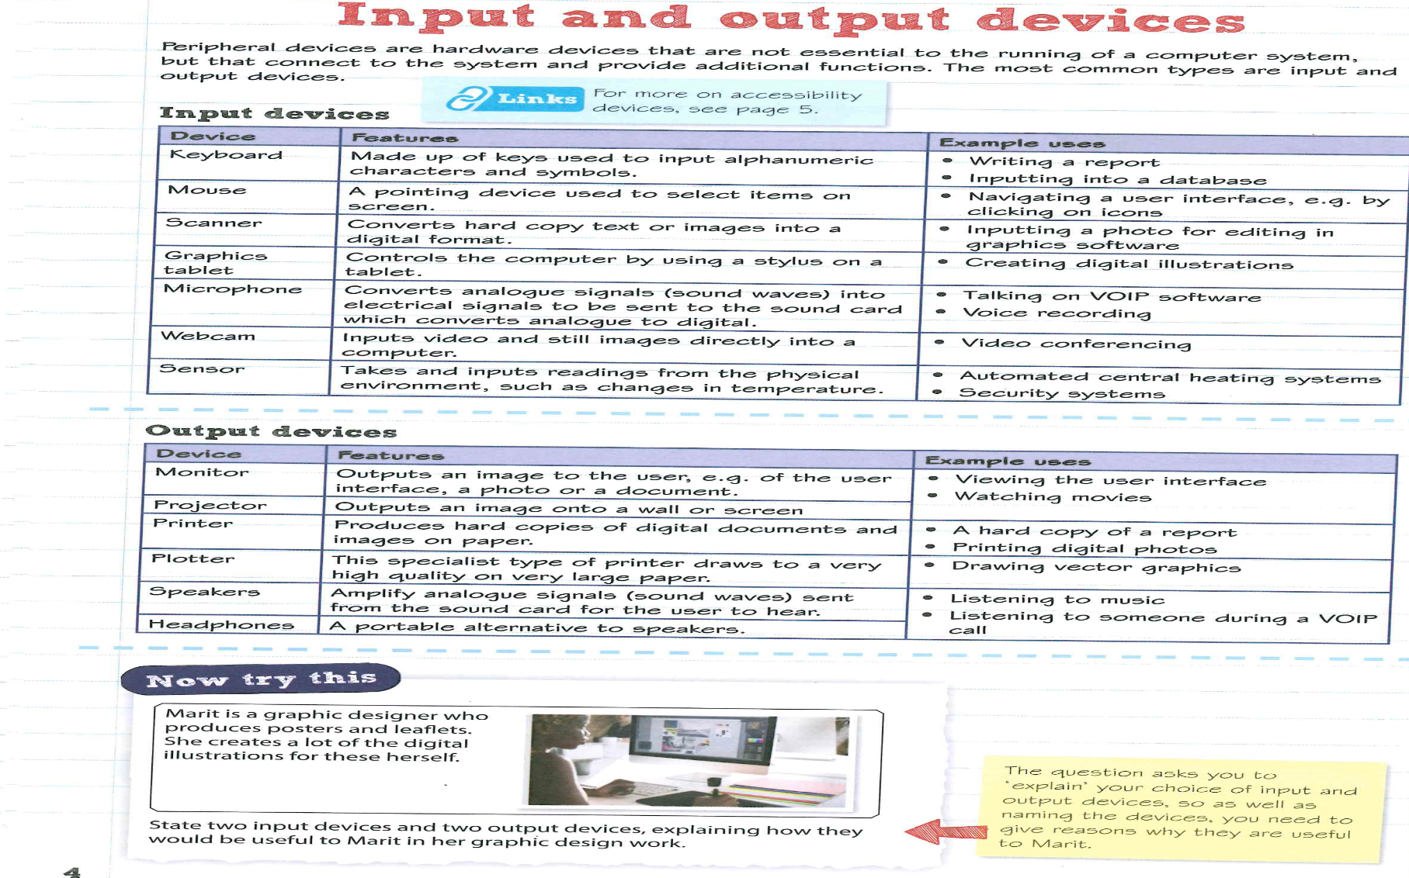

Task 1 - complete the grid below about input devices
Device | Image | main characteristics, | Example use with purpose and suitability of device
Mouse
Keyboard
Bar code reader
Flatbed scanner
Fingerprint scanner
Retina scanner
Iris scanner
Optical mark reader
Optical character reader
Smart card reader
RFID reader
Touch-sensitive screen
Graphics tablet
Voice recognition
Digital still camera

Task 2 - Complete the grid below about output devices
Device | Image | main characteristics, | Example use with purpose and suitability of device
LCD Screen
Plasma Screen
Speech input
Electronic paper
Impact printer
Inkjet printer
Laser printer

Task 3


