

Fulston Manor School

Anti-Bullying (Students) Policy

Version (Date): January 2026
Review (Date): January 2027

Member of Staff Responsible: Mr G Bowden
Deputy Headteacher

This policy should be read in conjunction with the Child Protection Policy and the Behaviour Policy. Fulston Manor School is committed to preventing all forms of child on child abuse.
We will work hard to ensure that bullying plays no part in our school community by proactively dealing with all students, their families and staff to promptly address all reported incidents. Bullying is a form of anti-social behaviour that has no place in our school community. Bullying is aggressive or insulting behaviour by an individual or group, often repeated over a period of time, which intentionally hurts or harms. This includes all forms of online and social media bullying. Bullying can produce feelings of powerlessness, isolation from others and undermine self-esteem. It can affect attitudes and performance in school. For some it can lead to serious and prolonged distress and long-term damage to social and emotional development.

This policy is based on DfE guidance “Preventing and Tackling Bullying” July 2017 and supporting documents. It also considers the DfE statutory guidance Keeping Children Safe in Education 2025 and Sexual violence and sexual harassment between children in schools and colleges guidance. This policy has also considered the guidance in Childnet’s “Cyberbullying: Understand, Prevent and Respond: Guidance for schools”.
This Anti-bullying Policy also embeds the key concepts of the Anti-Discrimination Law meaning that staff must act to prevent discrimination, harassment and victimisation within a school. This School sees the issue of bullying as a serious matter.

Aims/Statement of Intent:
All our staff, students and parents/carers at Fulston Manor school are working together to create a school community where bullying is not tolerated.

As a school we are committed to not only dealing with bullying but to do all that we can to prevent it happening in the ﬁrst place.

All students in our school should feel free from the threat of bullying and have the right to feel safe and secure. Students should know where to go and whom to speak to if bullying does occur. We will make students aware that all bullying concerns will be dealt with sensitively and effectively.

We expect a very high standard of self-discipline and behaviour from all our students. We hope that by encouraging students to adopt a caring and responsible attitude in school they will support each other to succeed. This is embedded in our ethos of everybody matters, everybody succeeds, everybody helps.
This is implemented in the support group approach of ‘Seven Steps’. We fully respect the need to change the behaviour of the bully, as well as creating a safe and secure environment for the victim.

Deﬁnitions of Bullying:

Bullying may be considered as: ‘deliberately hurtful; repeated over a period of time and difﬁcult for victims to defend themselves against’. It can appear in many forms including racial, gender, sexual orientation and disability or being a Young carer. (Or some other protected characteristic)

There are four main types of bullying:
Physical – e.g. Hitting, kicking, slapping, pinching, spitting, tripping, pushing and blocking. Stealing or destroying someone’s possessions. Being rude or making rude gestures. Touching in unwanted or inappropriate places.

Verbal - e.g. Name-calling, Insults, Teasing, Intimidation. Homophobic or racist remarks. Inappropriate sexual comments. Taunting. Threatening to cause harm.

Social – e.g. Lying and spreading rumours. Leaving someone out on purpose. Telling others not to be friends with someone. Embarrassing someone in public. Damaging someone’s reputation or relationship.

Cyber - e.g. Posting/sending hurtful texts, emails, posts, images or videos. Making online threats. Intimidating others online using their log-in. Deliberately excluding others online. Spreading nasty gossip or rumours online.

Strategies for Prevention/How to combat bullying:

As a school we are committed to not only dealing with bullying but we will try to do all that we can to prevent it happening in the ﬁrst place.

Students will be informed about our Anti-Bullying Policy via:
- Assemblies
- Newsletters
- Tutor time
- Anti-Bullying displays / Posters
- School website
- Personal Development Curriculum (PDC)

Staff will be informed about our Anti-Bullying Policy via:
- Inset days
- Staff Handbook
- Information booklets
- Anti-Bullying Policy

Parents/Carers will be informed about our Anti-Bullying Policy via:
- Newsletters
- New Parents Evenings and Progress Review Evenings
- School website
- Anti-Bullying Policy

In trying to create an ‘anti-bullying culture’ we take a preventative approach to bullying to safeguard the welfare of our students. We are committed to creating a school in which people treat others with respect. We have many strategies in place to enable us to do this:
- Peer Mentoring – older students support younger students during form time and encourage them to discuss any issues
- Students will be made aware of sanctions if bullying does occur
- Safe areas provided in school
- Staff supervision at break time, lunchtime and after school
- Anti-Bullying Surveys are conducted with all year groups
- Students are encouraged to ‘tell’ their Form Tutor, Head of House or any staff member that they can trust. This ‘tell’ message is relayed to all students through tutor time activities, assemblies and our PDC curriculum
- Problem solving, no blame approach to bullying is taken by our ‘Seven Steps’ approach
- Variety of activities on offer at lunchtime and after school, all supervised by staff
- Focus weeks on anti-bullying provide us with the platform to highlight bullying issues and talk freely during tutor time and PDC
- Competitions, such as anti-bullying posters created by students
- Promote our school ethos of everybody matters, everybody succeeds, everybody helps.
- Breakfast club is supervised by a member of staff from 8:00am every morning and provides opportunity and support for students before school
- Student Council allows student representatives to discuss any issues around anti-bullying
- Heads of House and members of support staff are trained in the ‘Seven Steps’ approach. They are available to discuss any concerns with students
- ‘Seven Steps’ approach is a non-blame approach which involves the process of trying to change the behaviour of the bully as well as create a safe and secure environment for the student

The Curriculum:

We aim to make anti-bullying initiatives an integral part of the curriculum for all years, with dedicated lessons during form time and PDC. Where appropriate, subject teachers encourage discussion, group work and cooperative learning to demonstrate the importance of respect and support of others.

We also raise student awareness and tolerance through assemblies, workshops, external programmes with external providers such as the Pride Trust, Stonewall etc. and Anti-Bullying Surveys.

Procedures for dealing with reported incidents:
All reported incidents will be dealt with sensitively and effectively by the member of staff to whom the incident was reported. They will deal with the incident following the ‘Seven Steps Approach’.

In some cases, it may be the parent or carer of a child or a member of staff who will report the incident, which will also be dealt with via the ‘Seven Steps Approach’.
The aim of the ‘Seven Steps Approach’ is to make the victim feel safe, whilst it will also challenge the behaviour of the bully in a no blame environment. The approach will encourage them to make positive suggestions as to how they can help the victim.

Seven Steps’ Approach:

STAGE 1
Step 1: Interview/talk with the victim about how they are feeling and the incident
When the member of staff ﬁnds out that the bullying has happened, they start by talking to the victim. During this conversation the member of staff listens and encourages the victim to describe how they are feeling.

The member of staff must ensure that the victim understands the process and gives consent to the member of staff meeting with the bully/bullies to discuss how the victim is feeling. Sometimes the victim may fear that it could lead to further incidents occurring but when the member of staff explains that it is a ‘no-blame approach’ then the victim is more likely to feel happier and safe.

Examples of questions you may want to ask:
- How are you feeling when you come into school?
- How is it affecting you at home?
- Have you talked to any of your friends about this?
- Have they suggested ways to help?
- I would like to tell these people how you are feeling, is that OK with you?
- Is there anything that you would not like me to tell them?

The member of staff should end the meeting by:
- Asking the victim to suggest the names of those involved, some colluders or observers and some friends who will make up the group
- Reassuring the victim that the group are not being punished but they are being made aware that their behaviour is unacceptable and they need to suggest ways to help the victim
- Offering the victim an opportunity to talk again at any time during the procedure if things are not going well
- Re-checking that nothing conﬁdential has been discussed which should not be disclosed to the group

Step 2: Arrange a meeting with the students involved

The member of staff should arrange a meeting with students who have been involved and suggested by the victim. The group should include some colluders or observers.
N.B. the victim is not present at the meeting

Step 3: Explain the problem

Tell the group about how the victim is feeling – do not discuss the details of the incident or allocate blame. Emphasise to the students that the victim doesn’t want to get them into trouble; they just want the bullying to stop.

Step 4: Share responsibility ‘No Blame’

When the member of staff has ﬁnished explaining, they need to inform the group that they are not going to be punished or get into trouble. Instead they have a responsibility to make the victims life happier in school and they should work together to solve the problem.

Step 5: Ask the group members for their ideas

Each member of the group is then encouraged to make suggestions as to how they can make the victim feel happier in school. Ideas are owned by the group members and not imposed by the member of staff.

STEP 6: Leave it up to them

The meeting is ended by responsibility being passed to the group to solve the problem. The member of staff then thanks the group for their positive responses and arranges to meet with them individually the following week.

STEP 7: Meet them again (individual interviews)

About a week later, the member of staff meets with the students and the victim. They discuss how things have been going. This allows the member of staff to monitor the bullying and keeps the students involved in the process.

Once a member of staff has dealt with an incident, they must ﬁll in an ‘anti bullying’ record and pass it on to the Head of House. The Head of House will log on CPOMS and provide a copy / send a notification to:
- Mr Abbott, Personal Development Leader
- Miss Spinola, Anti-Bullying Coordinator
- Mr Bowden, Deputy Headteacher (Pastoral)
N.B. If you are dealing with a racist incident then it must also be recorded accordingly in CPOMS.

STAGE 2
Parent/carer involvement.

STAGE 3
Sanction issued to the perpetrator or perpetrators. Where required, contact made with outside agencies.

STAGE 4
Pastoral Support Plan – Possible ﬁxed term suspension.

What happens if the bullying continues?

If the ‘Seven Steps Approach’ does not prevent bullying from reoccurring (e.g. persistent) or the incident is serious (e.g. damage, violence or theft), then other measures/sanctions will be needed:

Parental involvement of both the bully and victim
- Changes or Removal from form groups or class groups
- Student Agreement
- Exclusion from certain areas of school
- Potential Safeguarding concern
- Withdrawal at break or lunchtime
- Senior Leadership Team - lunchtime detention
- Withholding participation in any school trip or sports events that are not an essential part of the curriculum
- External agencies – including school engagement officers
- Managed Moves via Swale In-Year Fair Access
- Permanent exclusion

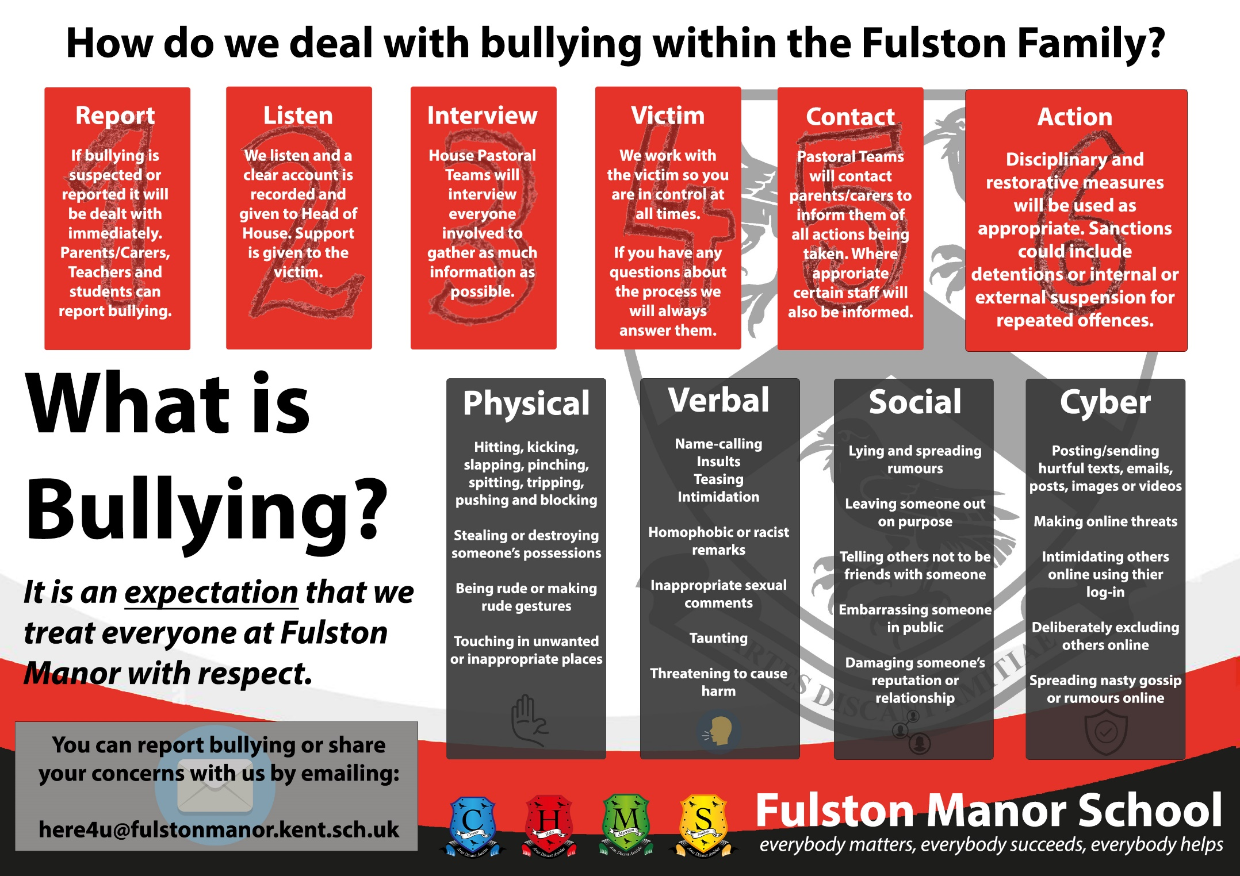

Cyber Bullying Guidance:

What is cyber bullying?
Cyber bullying is bullying through the use of communication technology like mobile phone text messages, emails, social media or websites. This can take many forms for example:
- Sending threatening or abusive messages or emails, personally or anonymously
- Making insulting comments about someone on a website, social networking site (e.g.: Instagram / Snapchat)
- Making or sharing derogatory or embarrassing videos of someone via mobile phone or email

It should be noted that the use of ICT to bully could be against the law.

Abusive language or images, used to bully, harass or threaten another, whether spoken or written (through electronic means) may be libelous and may contravene the Harassment Act 1997 or the Telecommunications Act 1984 for example.

At Fulston Manor School we believe that children should be conﬁdent in a no-blame culture when it comes to reporting inappropriate incidents involving the internet or mobile technology: they must be able to do this without fear.

If a bullying incident directed at a child occurs;
- Advise the child not to respond to the message
- Refer to the relevant Head of House, or Mr Bendon (Assistant Headteacher), they will then notify parents/carers
- Secure and preserve any evidence
- Consider informing the Police depending on the severity or repetitious nature of offence

If malicious or threatening comments are posted on an Internet site about a student you should;
- Inform and request the comments be removed if the site is administered externally
- Secure and preserve any evidence
- Send all the evidence to your child’s Head of House, parents/carers
- Endeavour to trace the origin and inform Police as appropriate

Homophobic Bullying Guidance:

What is homophobic/transphobic bullying or language?
Homophobic language means terms of abuse that are often used towards lesbian, gay, bisexual, transgender people, or those who identify as LGBTQ+. However, homophobic language is also often used to refer to something or someone as inferior. Phrases such as ‘those trainers are gay’, for example, may be used to insult someone or something, but without referring to actual or perceived sexual orientation. This language is often dismissed as ‘harmless banter’ and not thought to be particularly hurtful, especially where the intent is not to comment on someone’s actual or perceived sexual orientation. However, regardless of the lack of any deliberate intent, these terms liken being gay to something that’s bad, wrong or inferior.

Fulston Manor School endeavours to eliminate this sort of behaviour or use of this language. Our staff and students work together to create a school culture where homophobia and homophobic bullying are not tolerated.

Our school aims to intervene when young people use homophobic language, we will respond in the same way that we challenge racist language.

Fulston Manor School has various ways of addressing the issue homophobic bullying or language as indicated below:
- All staff will challenge homophobic behaviour or language every time they see or hear it
- Ensure that our students understand that homophobic behaviour or language is offensive and this is done via school assemblies and the school curriculum
- Involvement of the Leadership Group if homophobic behaviour or language persists
- Involvement of parents/carers if homophobic behaviour or language persists
- The school will address homophobia and LGBTQ+ equality in lessons
- Use of assemblies to address respect of and promote messages about LGBTQ+
- Use of posters around school to promote awareness
- Asking students their views of homophobic behaviour or language and how to tackle the problem

Any homophobic behaviour or language will be dealt with in accordance with the above approaches or where deemed necessary by using the ‘Seven Steps Approach’.

Transgender people commonly feel that their biological body is not aligned with their inner sense of gender identity. This leads some people to live in the gender role in which they feel more comfortable and which relates to their own sense of their gender identity rather than to their biological body.

Where children and young people are perceived not to be conforming to the dominant gender roles that may be widely expected of them, the school will be alert for signs of bullying.

The need to address sexist, sexual, and transphobic bullying will be viewed in the wider context of the academy’s duty to comply with the Public Sector Equality Duty under the Equality Act 2010, to promote student well-being, and to foster community cohesion. We understand that sexist, sexual and transphobic bullying is fundamentally an issue of equality. Although girls are most frequently harmed by sexist and sexual bullying, both sexual and transphobic bullying may affect boys and girls.

We will consider all students as potentially at risk of such bullying, particularly where they are perceived by others not to conform to dominant or stereotypical gender roles. The academy is committed to respecting the views of students in accordance to their human rights. The academy will respond to and prevent this type of bullying by following the DfE guidance “Preventing and Tackling Bullying” (July 2017), Keeping Children Safe in Education (2025), and DfE guidance on sexual violence and sexual harassment between children in schools and colleges (updated September 2021).

Young Carers Bullying Guidance
At Fulston Manor School we are aware that some students in our community have caring roles at home.

Deﬁnition of a Young Carer;
‘A young carer is a child or young person under the age of 18 who carries out signiﬁcant caring tasks and assumes a level of responsibility for another person which would normally be taken by an adult.’

We believe that all children and young people should have equal access to education, regardless of their circumstances at home and that whilst some children have to take on inappropriate or excessive levels of caring responsibilities we need to make sure that their educational needs are addressed.
When a young person does look after someone in their family who has a serious illness, disability, mental health issue or suffers a substance misuse problem, they may need a little extra support to help them get the most out of school.

We aim to understand the issues faced by Young Carers and support any student who helps to look after someone at home.
We aim to support Young Carers through a whole-school approach and through working with other agencies and professionals, with the understanding that support for the whole family is in the best interests of the Young Carer.

Swale Young Carers Service works in partnership with our school to offer appropriate support to young carers both within school and the wider community.
Any bullying towards Young Carers will be dealt with in accordance with the above approaches or where deemed necessary by using the ‘Seven Steps Approach’.

Child on Child Abuse Guidance
We recognise that children and young people are capable of abusing their peers and that child on child abuse can manifest in many different ways, including on-line bullying, youth produced imagery, criminal and sexual exploitation, initiation/hazing and inappropriate harmful sexual behaviours. It is very clear that this abuse should always be treated seriously and never just ‘banter’ or a ‘part of growing up’. Any concerns around peer on peer abuse must be reported and recorded in line with the Child Protection Procedures within the School. (Please refer to Child Protection Policy).

Sexual Violence and Sexual Harassment Guidance

Sexual Violence and Sexual Harassment is unwanted conduct of a sexual nature that may occur on or off line and can occur between two or more children of any age and gender. it can also occur through a group of children sexually assaulting or sexually harassing a single child or group of children. Sexual violence can occur online and ofﬂine and in physical, verbal or both.

Sexist Bullying - This is bullying based on sexist attitudes that when expressed demean, intimidate or harm another person because of their sex or gender. These attitudes are commonly based around the assumption that women are subordinate to men, or are inferior. Sexist bullying may sometimes be characterised by inappropriate sexual behaviours.

Sexual Bullying - This is bullying behaviour that has a speciﬁc sexual dimension or a sexual dynamic and it may be physical, verbal or non-verbal/psychological. Behaviours may involve suggestive sexual comments, including ‘sexting’ sexual bullying via a mobile device or innuendo including offensive comments about sexual reputation; or using sexual language that is designed to subordinate, humiliate or intimidate. It is also commonly methods of dealing with bullying of this nature: underpinned by sexist attitudes or gender stereotypes.

Upskirting - This behaviour involves taking a picture under a person’s clothing without them knowing, with the intention of viewing their genitals or buttocks to obtain sexual gratiﬁcation, or cause the victim humiliation, distress or alarm. This is a criminal offence and any incident of ‘upskirting’ within the school will be reported to the Police.

The school will take all forms of Sexual Violence and Sexual Harassment seriously. The School is aware that some groups may also potentially be at more risk.
Evidence shows that girls, children with SEND and the LGBTQ+ community are more at risk. The school will ensure that an appropriate ‘Protective’ Curriculum is in place to educate and safeguard young people within the school about such issues.

We understand that sexist, sexual and transphobic bullying is fundamentally an issue of equality. Although girls are most frequently harmed by sexist and sexual bullying, both sexual and transphobic bullying may affect boys and girls. We will consider all students as potentially at risk of such bullying, particularly where they are perceived by others not to conform to dominant or stereotypical gender roles. The school will respond to and prevent this type of bullying by following the DfE guidance “Preventing and Tackling Bullying” (July 2017), Keeping Children Safe in Education (2025), and the DfE guidance on sexual violence and sexual harassment between children in schools and colleges (updated September 2021), which collectively encompass expectations for preventing and responding to sexist, sexual, homophobic and transphobic bullying.

Monitoring and evaluating the policy
The school will review the Anti-Bullying Policy annually, which will be ratiﬁed by the Headteacher.
Annually the policy will be assessed as to its implementation, effectiveness and success throughout the academy.

The criteria of Anti-Bullying Policy success will be evident through the following:
- By checking how many incidents have been reported and dealt within the last year
- By seeking parents’ views
- By seeking staff views via the Teacher Survey
- By seeking students’ views using the Student Forum
- Regular reminders about the policy to staff and students
- Evidence from across the school
- Complaints from staff, students and parents and carers
- Homophobic and racist incident log

Conclusion
At Fulston Manor School we consider bullying to be against our underlying ethos of everybody matters, everybody succeeds, everybody helps. We must all act in a consistent, supportive and sympathetic way when dealing with issues of bullying.

If you need to contact our school or require further information/help, then please contact us on: 01795 475228 or email us at: mail@fulstonmanor.kent.sch.uk
You can report bullying or share your concerns with us by emailing here4u@fulstonmanor.kent.sch.uk

Useful contacts for parents/carers
- Kidscape: 08451 205204 or h ttps://www.kidscape.org.uk/
- Family Lives: 0808 800 2222
- NSPCC: 0808 800 5000 or https://www.nspcc.org.uk/
- Anti Bullying Alliance: 020 7843 1901 or w ww.antibullyingalliance.org
- CEOP: https://www.ceop.police.uk/safety-centre/
- Childline: 0800 1111 or h ttps://www.childline.org.uk/
- GOV.UK: https://www.gov.uk/government/publications/preventing-and-tackling-bullying
- Stonewall: https://www.stonewall.org.uk/

