BTEC Level 3 IT
PART 4 – DEVICES FOR ACCESSIBILTY & DATA PROCESSING
Read the information and complete the tasks on the next page
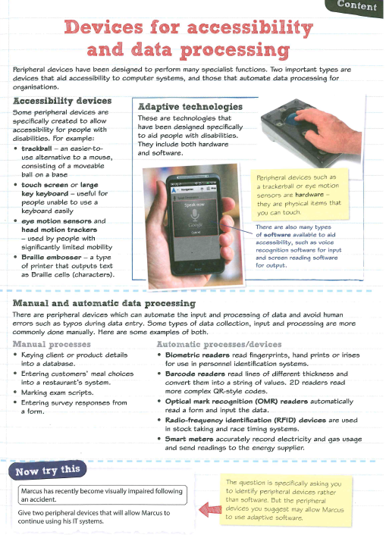

Task 1 - in terms of computing and IT what does accessibility mean?
Task 2 complete the table below

Accessibility issue | Describe an Input device that could help | Describe an output device that could help | Describe a software tool that could help
I can't see very well
I can't hear very well
I find using a keyboard or mouse difficult
I am blind
I find words difficult

Task 3

Task 4
What is the difference between manual and automated data entry
Task 5
How could an RFID change improve the life experiences of a paraplegic student.

