Eukaryotic and Prokaryotic
- Prokaryotes (pro-kary-otes) are single celled organisms made from prokaryotic cells.
- Eukaryotes (You-kary-otes) are made from eukaryotic cells.
- Prokaryotic cells tend to be simpler and smaller (e.g.bacteria), whereas eukaryotic cells tend to be more complex and larger (e.g. plant cells or animals cells)
- Both types of cell contain organelles, which have specific functions. Some organelles are common to both prokaryotes and eukaryotes.
Task: Label the organelles and state their functions. Make a table for the functions if you do not have enough space to write them on the diagram.
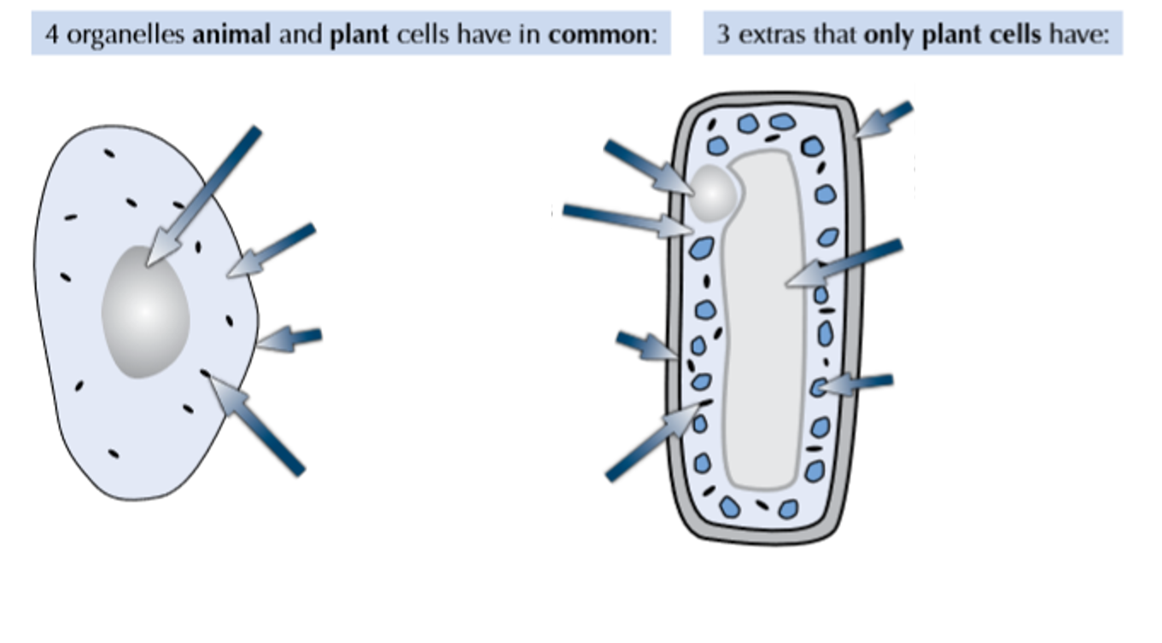
Bacterial cells are prokaryotic
- Approximately, how much smaller are prokaryotic cells than eukaryotic cells?
- State the organelles you would not find in prokaryotes.
- How is the DNA arranged and stored differently in prokaryotes? Why?
- Some bacteria have a flagellum. What is a flagellum? What is its function? How does it achieve this?
- Give an example of a prokaryotic cell.
Eukaryotes are…
- Name four organelles that plant and animals cells both have.
- What is the function of mitochondria?

