Enzymes
In a living cell, thousands of biochemical reactions take place every second. The sum of these reactions is called metabolism. A single chain of these reactions is called a metabolic pathway. Without enzymes, these reactions would take place very slowly at normal body temperature. Enzymes Help to Speed up Biochemical Reactions and we therefore can say that:
- Enzymes are biological catalysts.
- They increase the rate (speed) of reactions.
Even reactions that release energy require an input of energy to get them going, e.g. the gas from a Bunsen burner doesn’t burn until you provide heat energy from a match.
This input energy is called the activation energy. A reaction that needs a high activation energy can’t start at a low temperature of 37 °C (i.e. body temperature).
Enzymes reduce the activation energy.
The graph shows the energy of molecules involved in a reaction as the reaction takes place. It shows two curves that represent a reaction taking place with an enzyme and the same reaction taking place without an enzyme.
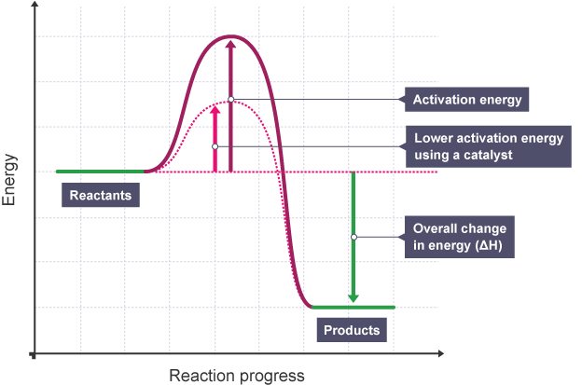

Task 1: Label the curves “reaction with enzyme” and “reaction without enzyme”.
Back to proteins?!
Task 2: Research the following questions about enzymes
- Which type of protein are enzymes?
- What determines the structure (and shape of the active site), and therefore the function of an enzyme?
- Give an example of an enzyme that helps by breaking large molecules into smaller ones, and an example of an enzyme that joins small molecules together to make a large one. Try to find the name of the enzyme, the small molecules (monomers) it breaks apart or joins up and the large molecule (polymer) they make.
- What is the function of enzymes?
- What is activation energy?
- What do digestive enzymes do?

