**Area under a graph**

**A LEVEL LINKS**

**Scheme of work:** 7b. Definite integrals and areas under curves

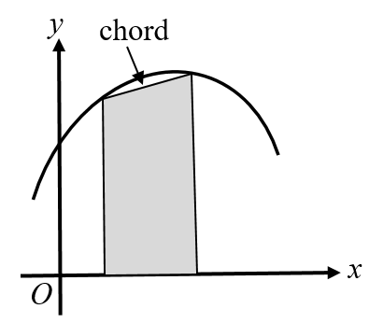Key points

* To estimate the area under a curve, draw a chord between the two points you are finding the area between and straight lines down to the horizontal axis to create a trapezium.   
  The area of the trapezium is an approximation for the area under a curve.

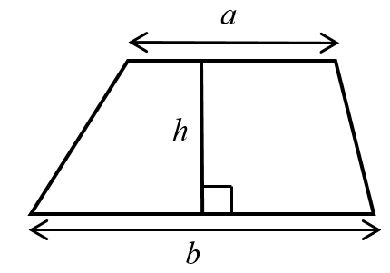

* The area of a trapezium = 

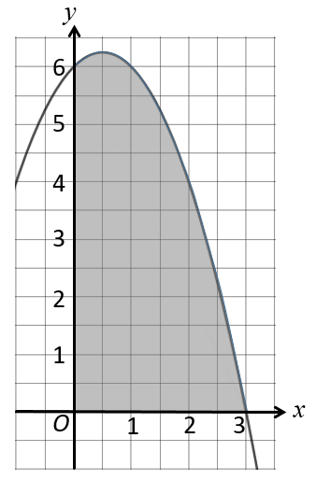Examples

**Example 1** Estimate the area of the region between the curve   
*y* = (3 − *x*)(2 + *x*) and the *x*-axis from *x* = 0 to *x* = 3.   
Use three strips of width 1 unit.

|  |  |  |  |  |  |  |  |  |  |  |  |
| --- | --- | --- | --- | --- | --- | --- | --- | --- | --- | --- | --- |
| |  |  |  |  |  | | --- | --- | --- | --- | --- | | ***x*** | 0 | 1 | 2 | 3 | | ***y* = (3 − *x*)(2 + *x*)** | 6 | 6 | 4 | 0 |   Trapezium 1:  ,  Trapezium 2:  ,  Trapezium 3:  , | **1** Use a table to record the value of *y* on the curve for each value of *x*.  **2** Work out the dimensions of each trapezium. The distances between the *y*-values on the curve and the  *x*-axis give the values for *a*.  *(continued on next page)* |
| Area = 6 + 5 + 2 = 13 units2 | **3** Work out the area of each trapezium. *h* = 1 since the width of each trapezium is 1 unit.  **4** Work out the total area. Remember to give units with your answer. |

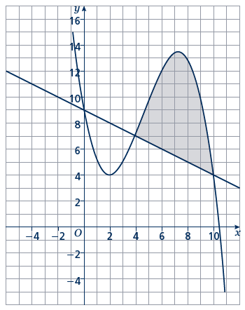

**Example 2** Estimate the shaded area.   
 Use three strips of width 2 units.

|  |  |  |  |  |  |  |  |  |  |  |  |  |  |  |  |  |  |  |  |  |  |
| --- | --- | --- | --- | --- | --- | --- | --- | --- | --- | --- | --- | --- | --- | --- | --- | --- | --- | --- | --- | --- | --- |
| |  |  |  |  |  | | --- | --- | --- | --- | --- | | ***x*** | 4 | 6 | 8 | 10 | | ***y*** | 7 | 12 | 13 | 4 |  |  |  |  |  |  | | --- | --- | --- | --- | --- | | ***x*** | 4 | 6 | 8 | 10 | | ***y*** | 7 | 6 | 5 | 4 |   Trapezium 1:  ,  Trapezium 2:  ,  Trapezium 3:  ,        Area = 6 + 14 + 8 = 28 units2 | **1** Use a table to record *y* on the curve for each value of *x*.  **2** Use a table to record *y* on the straight line for each value of *x*.  **3** Work out the dimensions of each trapezium. The distances between the *y*-values on the curve and the  *y*-values on the straight line give the values for *a*.  **4** Work out the area of each trapezium. *h* = 2since the width of each trapezium is 2 units.  **5** Work out the total area. Remember to give units with your answer. |

Practice

**Hint:**

For a full answer, remember to include ‘units2’.

**1** Estimate the area of the region between the curve *y* = (5 − *x*)(*x* + 2) and the *x*-axis from *x* = 1 to *x* = 5.   
 Use four strips of width 1 unit.

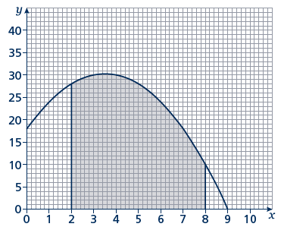

**2** Estimate the shaded area shown on the axes.   
 Use six strips of width 1 unit.

**3** Estimate the area of the region between the curve *y* = *x*2 − 8*x* + 18 and the *x*-axis   
 from *x* = 2 to *x* = 6.   
 Use four strips of width 1 unit.

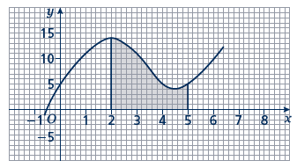**4** Estimate the shaded area.   
 Use six strips of width  unit.

**5** Estimate the area of the region between the curve *y* = −*x*2 − 4*x* + 5 and the   
 *x*-axis from *x* = −5 to *x* = 1.   
 Use six strips of width 1 unit.

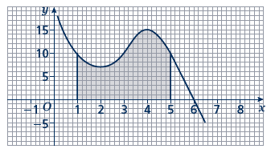

**6** Estimate the shaded area.   
 Use four strips of equal width.

**7** Estimate the area of the region between the curve *y* = −*x*2 + 2*x* + 15 and the   
 *x*-axis from *x* = 2 to *x* = 5.   
 Use six strips of equal width.

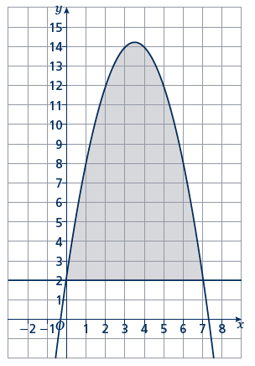

**8** Estimate the shaded area.   
 Use seven strips of equal width.

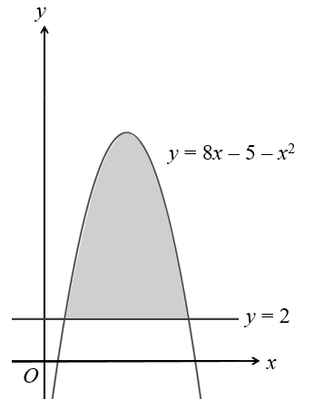Extend

**9** The curve *y* = 8*x* − 5 − *x*2 and the line *y* = 2   
 are shown in the sketch.   
 Estimate the shaded area using six strips   
 of equal width.

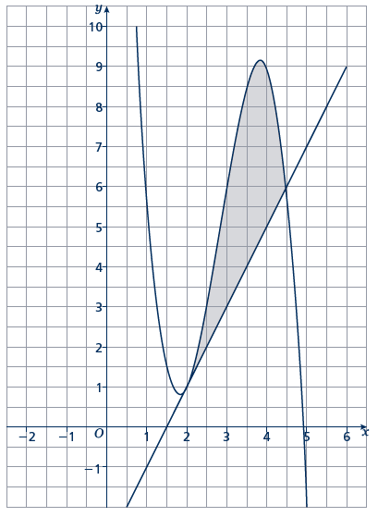**10** Estimate the shaded area using five  
 strips of equal width.

Answers

**1** 34 units2

**2** 149 units2

**3** 14 units2

**4** 25 units2

**5** 35 units2

**6** 42 units2

**7** 26 units2

**8** 56 units2

**9** 35 units2

**10** 6 units2